Hackerrank SQL題

題目最好都看本文件中的題目, 因為網頁上的題目有的意思不明(或意思錯), 有的的表故意刷屏. 本文件把這些問題都消除了.

以下代碼都是在MySQL中通過的. 用MySQL是因為Chase那人發給我的Data Science Resources中說: I suggest installing MySQL on your computer and playing with that; it's pretty easy to install and use.

Basic Select

Revising the Select Query I , Easy

Query all columns for all American cities in CITY with populations larger than 100000. The CountryCode for America is USA.

Input Format

The CITY table is described as follows:
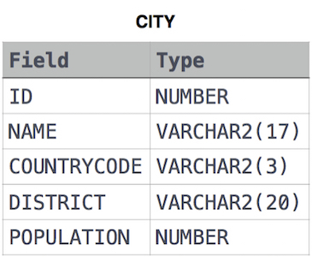

History:
E1幾分鍾寫好, 改了POPULATION的typo後即通過. E1代碼跟Top Solution中的一樣. Discussion中有些代碼也是用的大寫(SELECT, WHERE等). 這是我人生刷的第一邊SQL題, 也是人生第一次自己寫SQL代碼.

E1代碼:
SELECT *
FROM CITY
WHERE COUNTRYCODE = 'USA' AND POPULATION > 100000;

上句不要分號也能通過, Top Solution中有些人就沒用分號.
大小寫也無所謂, FROM CITY寫為fRoM cItY, 也能通過. 後面的題表明, count寫為cOUnt 也能通過.

Revising the Select Query II, Easy

Query the names of all American cities in CITY with populations larger than 120000. The CountryCode for America is USA.

Input Format

The CITY table is described as follows (CITY table圖見本文件夾).

History:
E1一分鍾寫好, 一次通過, 代碼跟Top Solution中的一樣.

E1的代碼:
SELECT NAME
FROM CITY
WHERE COUNTRYCODE = 'USA' AND POPULATION > 120000;

Select All , Easy

Query all columns (attributes) for every row in the CITY table.

Input Format

The CITY table is described as follows (CITY table圖見本文件夾).

History:
E1幾秒鍾寫好, 一次通過, 代碼跟Top Solution中的一樣.

E1的代碼:
SELECT *
FROM CITY;

Select By ID, Easy

Query all columns for a city in CITY with the ID 1661.

Input Format

The CITY table is described as follows (CITY table圖見本文件夾).

History:
E1幾秒鍾寫好, 一次通過, 代碼跟Top Solution中的一樣. 這些題目太簡單, 略浪費我時間.

E1的代碼:
SELECT *
FROM CITY
WHERE ID = 1661;

Japanese Cities' Attributes, Easy

Query all attributes of every Japanese city in the CITY table. The COUNTRYCODE for Japan is JPN.

Input Format

The CITY table is described as follows (CITY table圖見本文件夾).
History:
E1幾秒鍾寫好, 一次通過, 代碼跟Top Solution中的一樣.

E1的代碼:
SELECT *
FROM CITY
WHERE COUNTRYCODE = 'JPN'

Japanese Cities' Names, Easy

Query the names of all the Japanese cities in the CITY table. The COUNTRYCODE for Japan is JPN.

Input Format

The CITY table is described as follows (CITY table圖見本文件夾).

History:
E1幾秒鍾寫好, 一次通過, 代碼跟Top Solution中的一樣.

E1的代碼:
SELECT NAME
FROM CITY
WHERE COUNTRYCODE = 'JPN';

Weather Observation Station 1, Easy

Query a list of CITY and STATE from the STATION table.

Input Format

The STATION table is described as follows:

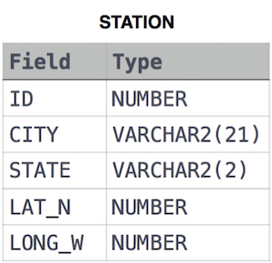

History:
E1幾秒鍾寫好, 一次通過, 代碼跟Top Solution中的一樣.

E1的代碼:
SELECT CITY, STATE
FROM STATION;

Weather Observation Station 3, Easy

Query a list of CITY names from STATION with even ID numbers only. You may print the results in any order, but must exclude duplicates from your answer.

Input Format

The STATION table is described as follows (STATION table圖見本文件夾).

History:
E1一分鍾寫好, 一次通過, 代碼跟Top Solution中的一樣. Weather Observation Station 2在Aggregation的那類題目中.

E1的代碼:
SELECT DISTINCT(CITY)
FROM STATION
WHERE MOD(ID, 2) = 0;

上句寫為WHERE ID % 2 = 0;也能通過, Top Solution中有的人用的MOD, 有的用的%.

Weather Observation Station 4, Easy

Let be the number of CITY entries in STATION, and let be the number of distinct CITY names in STATION; query the value of from STATION. In other words, find the difference between the total number of CITY entries in the table and the number of distinct CITY entries in the table.

Input Format

The STATION table is described as follows (STATION table圖見本文件夾).

History:
E1沒做出來, 看的Discussion. Discussion中的代碼也通不過, E1小改後即通過.

Top Solution的代碼(E1小改後):
SELECT (count(CITY) - count(DISTINCT(CITY)))
FROM STATION;

以上count寫為cOUnt, 也能通過.

Weather Observation Station 5, Easy

Query the two cities in STATION with the shortest and longest CITY names, as well as their respective lengths (i.e.: number of characters in the name). If there is more than one smallest or largest city, choose the one that comes first when ordered alphabetically.

Input Format

The STATION table is described as follows (STATION table圖見本文件夾).

where LAT_N is the northern latitude and LONG_W is the western longitude.

Sample Input

Let's say that CITY only has four entries: DEF, ABC, PQRS and WXY

Sample Output

ABC 3
PQRS 4
Explanation

When ordered alphabetically, the CITY names are listed as ABC, DEF, PQRS, and WXY, with the respective lengths and . The longest-named city is obviously PQRS, but there are options for shortest-named city; we choose ABC, because it comes first alphabetically.

History:
E1沒做出來.

Top Solution:
SELECT MIN(CITY), LENGTH(CITY)
FROM STATION
GROUP BY LENGTH(CITY)
ORDER BY LENGTH(CITY) limit 1;

SELECT MIN(CITY), LENGTH(CITY)
FROM STATION
GROUP BY LENGTH(CITY)
ORDER BY LENGTH(CITY) desc limit 1;

以上代碼的解釋:
看SQL-pick-up這個文件中對Group by的講解, 就明白了. 本代碼可以類似理解: 第一段代碼即, 先將所有CITY按其長度分group, 相同長度的為一個group. 然後在每一個group中, 返回alphabetically 最小的CITY 及其 長度. 將結果按CITY長度 從小到大排列, 並只返回一個(即limit 1).

The SQL SELECT LIMIT statement is used to retrieve records from one or more tables in a database and limit the number of records returned based on a limit value.

TIP: SELECT LIMIT is not supported in all SQL databases. 但以上代碼可在MySQL中通過.

Weather Observation Station 6, Easy

Query the list of CITY names starting with vowels (a, e, i, o, u) from STATION. Your result cannot contain duplicates.

Input Format

The STATION table is described as follows (STATION table圖見本文件夾).

where LAT_N is the northern latitude and LONG_W is the western longitude.

History:
E1幾分鍾寫好, 一次通過. E1是用的LIKE 'a%'等, 代碼不及Top Solution的REGEXP簡明. 以下把E1和Top Solution都帖出來. 由於我對 regular expression不熟, 所以還是要主要掌握我E1的代碼.

E1的代碼:
SELECT DISTINCT(CITY)
FROM STATION
WHERE CITY LIKE 'a%' OR CITY LIKE 'e%' OR CITY LIKE 'i%' OR CITY LIKE 'o%' OR CITY LIKE 'u%';

Top Solution:
SELECT DISTINCT city
FROM station
WHERE city REGEXP "^[aeiou].*";

以上的雙引號改為單引號也能通過.

From Wiki Regular expression (注意沒說是SQL, 說明是通用的)(以下符號都是後面題目中會用到的):
^ Matches the starting position within the string.
$ Matches the ending position of the string or the position just before a string-ending newline.
[ ] A bracket expression. Matches a single character that is contained within the brackets. For
example, [abc] matches "a", "b", or "c". [a-z] specifies a range which matches any lowercase
letter from "a" to "z". These forms can be mixed: [abcx-z] matches "a", "b", "c", "x", "y", or "z",
as does [a-cx-z].
[^ ] Matches a single character that is not contained within the brackets. For example, [^abc]
matches any character other than "a", "b", or "c". [^a-z] matches any single character that is not
a lowercase letter from "a" to "z". Likewise, literal characters and ranges can be mixed.
. Matches any single character (many applications exclude newlines )
* Matches the preceding element zero or more times. For example, ab*c matches "ac", "abc",
"abbbc", etc. [xyz]* matches "", "x", "y", "z", "zx", "zyx", "xyzzy", and so on. (ab)* matches "",
"ab", "abab", "ababab", and so on.

Weather Observation Station 7, Easy

Query the list of CITY names ending with vowels (a, e, i, o, u) from STATION. Your result cannot contain duplicates.

Input Format

The STATION table is described as follows (STATION table圖見本文件夾).

where LAT_N is the northern latitude and LONG_W is the western longitude.

History:
E1最開始用%通過, 然後想寫Regular expression, 寫成的是"[aeiou].*$", 結果沒通過, 後來看Discussion才知道是 "[aeiou]$", 俱體原因不大清楚.

Top Solution:
SELECT DISTINCT(CITY)
FROM STATION
WHERE CITY REGEXP "[aeiou]$";

E1的代碼:
SELECT DISTINCT(CITY)
FROM STATION
WHERE CITY LIKE '%a' OR CITY LIKE '%e' OR CITY LIKE '%i' OR CITY LIKE '%o' OR CITY LIKE '%u';

Weather Observation Station 8, Easy

Query the list of CITY names from STATION which have vowels (i.e., a, e, i, o, and u) as both their first and last characters. Your result cannot contain duplicates.

Input Format

The STATION table is described as follows(STATION table圖見本文件夾).

where LAT_N is the northern latitude and LONG_W is the western longitude.

History:
E1改了幾次後才通過. Discussion中的代碼都沒我好E1好.

E1的代碼:
SELECT DISTINCT(CITY)
FROM STATION
WHERE CITY REGEXP "^[aeiou].*[aeiou]$";

Weather Observation Station 9, Easy

Query the list of CITY names from STATION that do not start with vowels. Your result cannot contain duplicates.

Input Format

The STATION table is described as follows (STATION table圖見本文件夾).

where LAT_N is the northern latitude and LONG_W is the western longitude.

History:
E1用的NOT IN, 一次通過. E1代碼沒有Top Solution好, 以後用Top Solution.

Top Solution:
SELECT DISTINCT CITY
FROM STATION
WHERE CITY REGEXP '^[^aeiou]';

E1的代碼:
SELECT DISTINCT (CITY)
FROM STATION
WHERE CITY NOT IN
(SELECT DISTINCT(CITY)
FROM STATION
WHERE CITY REGEXP "^[aeiou].*");

Weather Observation Station 10, Easy

Query the list of CITY names from STATION that do not end with vowels. Your result cannot contain duplicates.

Input Format

The STATION table is described as follows (STATION table圖見本文件夾).

where LAT_N is the northern latitude and LONG_W is the western longitude.

History:
E1一分鍾寫好, 一次通過. Discussion中的代碼都是用的NOT IN甚麼的, 沒有我E1的好.

E1的代碼:
SELECT DISTINCT(CITY)
FROM STATION
WHERE CITY REGEXP "[^aeiou]$";

Weather Observation Station 11, Easy

Query the list of CITY names from STATION that either do not start with vowels or do not end with vowels. Your result cannot contain duplicates.

Input Format

The STATION table is described as follows (STATION table圖見本文件夾).

where LAT_N is the northern latitude and LONG_W is the western longitude.

History:
E1最開始把題目看錯了, 將or看成了and. 改後即通過. Discussion中的代碼都沒E1的好.

E1的代碼:
SELECT DISTINCT(CITY)
FROM STATION
WHERE CITY REGEXP "^[^aeiou].*" OR CITY REGEXP "[^aeiou]$";

Weather Observation Station 12, Easy

Query the list of CITY names from STATION that do not start with vowels and do not end with vowels. Your result cannot contain duplicates.

Input Format

The STATION table is described as follows (STATION table圖見本文件夾).

where LAT_N is the northern latitude and LONG_W is the western longitude.

History:
E1一分鍾寫好, 一次通過. Discussion中有人代碼跟我E1一樣.

E1的代碼:
SELECT DISTINCT (CITY)
FROM STATION
WHERE CITY REGEXP "^[^aeiou].*[^aeiou]$";

Higher Than 75 Marks, Easy

Query the Name of any student in STUDENTS who scored higher than 75 Marks. Order your output by the last three characters of each name. If two or more students both have names ending in the same last three characters (i.e.: Bobby, Robby, etc.), secondary sort them by ascending ID.

Input Format

我將以下的表放在了同一行, 好方便看.

The STUDENTS table is described as follows:

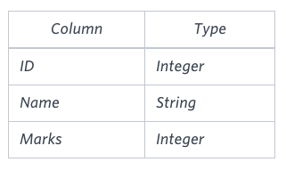
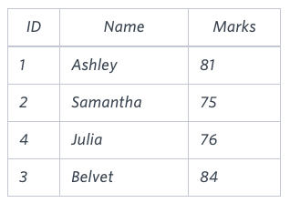

STUDENTS

Sample Input

The Name column only contains uppercase (A-Z) and lowercase (a-z) letters.

Sample Output

Ashley
Julia
Belvet
Explanation

Only Ashley, Julia, and Belvet have Marks > 75. If you look at the last three characters of each of their names, there are no duplicates and 'ley' < 'lia' < 'vet'.

History:
E1沒通過, 原因是寫了兩行ORDER BY, 看了答案後才知道兩行ORDER BY應該寫到一行.

Top Solution:
Select Name
from STUDENTS
where Marks > 75
ORDER BY substr(Name,-3,3),ID;

以上最後一句寫為ORDER BY substr(Name,length(Name)-2,3),ID;也能通過, 但length不能寫為len.

SUBSTRING (expression, start, length): 函數意思自明. 要特別注注意的是, SQL中string中的字符指標是從1開始的, 而不是從0開始, 例如:

SELECT SUBSTR(Store_Name,2,4)
FROM Geography
WHERE Store_Name = 'San Diego';

結果:
'an D'

這就是為甚麼本題中應寫為substr(Name,length(Name)-2,3), 而不是substr(Name,length(Name)-3,3).

Employee Names, Easy

Write a query that prints a list of employee names (i.e.: the name attribute) from the Employee table in alphabetical order.

Input Format

我將以下的表放在了同一行, 好方便看.

The Employee table containing employee data for a company is described as follows:
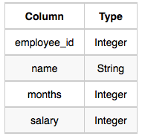
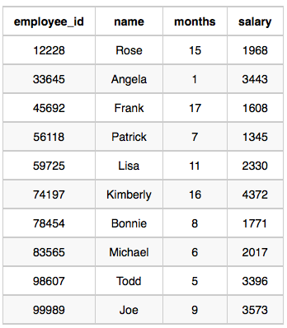

Employee

Sample Input

where employee_id is an employee's ID number, name is their name, months is the total number of months they've been working for the company, and salary is the their monthly salary.

Sample Output

Angela
Bonnie
Frank
Joe
Kimberly
Lisa
Michael
Patrick
Rose
Todd

History:
E1幾秒鍾寫好, 一次通過. Discussion中也是E1這樣寫的.

E1的代碼:
SELECT name
FROM Employee
ORDER BY name;

Employee Salaries, Easy

Write a query that prints a list of employee names (i.e.: the name attribute) for employees in Employee having a salary greater than $2000 per month who have been employees for less than 10 months. Sort your result by ascending employee_id.

Input Format

The Employee table containing employee data for a company is described as follows (Employee和Sample Input的圖都同上題).

where employee_id is an employee's ID number, name is their name, months is the total number of months they've been working for the company, and salary is the their monthly salary.

Sample Output

Angela
Michael
Todd
Joe

Explanation

Angela has been an employee for 1 month and earns $3443 per month.
Michael has been an employee for 6 months and earns $2017 per month.
Todd has been an employee for 5 months and earns $3396 per month.
Joe has been an employee for 9 months and earns $3573 per month.
We order our output by ascending employee_id.

History:
E1一分鍾寫好, 一次通過. Discussion中也是這樣寫的.

E1的代碼:
SELECT name
FROM Employee
WHERE salary > 2000 AND months < 10
ORDER BY employee_id;

Advanced Select (沒做)

Aggregation

Revising Aggregations - The Count Function, Easy

Query a count of the number of cities in CITY having a Population larger than 100,000.

Input Format

The CITY table is described as follows (CITY table圖見本文件夾).

History:
E1幾秒鍾寫好, 結果把POPULATION 一詞寫錯了, 改後即通過. Discussion中也是這樣寫的.

E1的代碼:
SELECT count(*)
FROM CITY
WHERE POPULATION > 100000;

Revising Aggregations - The Sum Function, Easy

Query the total population of all cities in CITY where District is California.

Input Format

The CITY table is described as follows (CITY table圖見本文件夾).

History:
E1幾秒鍾寫好, 結果把SUM寫為了COUNT, 'CALIFORNIA'也忘了加單引號, 改後即通過. Discussion中也是這樣寫的.

E1的代碼:
SELECT SUM(POPULATION)
FROM CITY
WHERE DISTRICT = 'CALIFORNIA';

Revising Aggregations - Averages, Easy

Query the average population of all cities in CITY where District is California.

Input Format

The CITY table is described as follows (CITY table圖見本文件夾).

History:
E1幾秒鍾寫好, 一次通過. Discussion中也是這樣寫的.

E1的代碼:
SELECT AVG(POPULATION)
FROM CITY
WHERE DISTRICT = 'CALIFORNIA';

Average Population, Easy

Query the average population for all cities in CITY, rounded down to the nearest integer.

Input Format

The CITY table is described as follows (CITY table圖見本文件夾).

History:
E1最開始把題目看錯了, 以為還要求是California, 改後即通過. Discussion中也是這樣寫的.

E1的代碼:
SELECT FLOOR(AVG(POPULATION))
FROM CITY;

From online:
FLOOR(), if you want to round your decimal to the lower integer. Examples:
FLOOR(12345.7344) => 12345

ROUND(), if you want the nearest integer to the argument. Examples:
ROUND(12345.7344) => 12346
ROUND(12345.4311) => 12345

CEIL(), if you want to round your decimal to the upper integer. Examples:
CEIL(12345.4311) => 12346

Japan Population, Easy

Query the sum of the populations for all Japanese cities in CITY. The COUNTRYCODE for Japan is JPN.

Input Format

The CITY table is described as follows (CITY table圖見本文件夾).

History:
E1幾秒鍾寫好, 一次通過. Discussion中也是這樣寫的.

E1的代碼:
SELECT SUM(POPULATION)
FROM CITY
WHERE COUNTRYCODE = 'JPN';

Population Density Difference, Easy

Query the difference between the maximum and minimum populations in CITY.

Input Format

The CITY table is described as follows (CITY table圖見本文件夾).

History:
E1幾秒鍾寫好, 一次通過. Discussion中也是這樣寫的.

E1的代碼:
SELECT MAX(POPULATION) - MIN(POPULATION)
FROM CITY;

The Blunder, Easy

以下題目廢話太多. 我將題意簡寫於此, 不用再看題目. 稱以下EMPLOYEES 表(即第一個表)中的平均Salary為actual. EMPLOYEES表的一個例子即為以下第二個表. 現在要將第二個表中所有Salary中的0都去掉, 變成以下第三個表那樣, 稱第三個表中的平均Salary為 miscalculated. 求(actual - miscalculated), 並將結果 round up to the next integer.

Samantha was tasked with calculating the average monthly salaries for all employees in the EMPLOYEES table, but did not realize her keyboard's 0 key was broken until after completing the calculation. She wants your help finding the difference between her miscalculation (using salaries with any zeroes removed), and the actual average salary.

Write a query calculating the amount of error (i.e.: actual - miscalculated average monthly salaries), and round it up to the next integer.

Input Format

我將以下的表都放在了同一行, 好方便看.

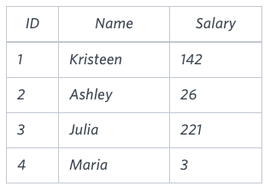
The EMPLOYEES table is described as follows:
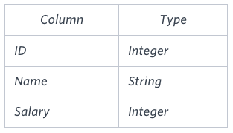
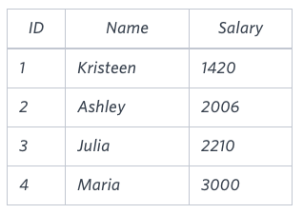

EMPLOYEES Sample Input Explanation

Note: Salary is measured in dollars per month and its value is < 10^5.

Sample Output

2061

Explanation

The table below (見上) shows the salaries without zeroes as they were entered by Samantha:

Samantha computes an average salary of 98.00. The actual average salary is 2159.00.

The resulting error between the two calculations is 2159.00 - 98.00 = 2061.00 which, when rounded to the next integer, is 2061.

History:
E1直接看的答案.

Top Solution:
SELECT CEIL(AVG(SALARY) - AVG(REPLACE(SALARY, '0', '')))
FROM EMPLOYEES;

REPLACE(string1, string_to_replace, replacement_string), 作用自明. 例子:
SELECT REPLACE('TechOnTheNet.com', 'Tech', '1234');
Result: '1234OnTheNet.com'

Top Earners, Easy

We define an employee's total earnings to be their monthly salary * months worked, and the maximum total earnings to be the maximum total earnings for any employee in the Employee table. Write a query to find the maximum total earnings for all employees as well as the total number of employees who have maximum total earnings. Then print these values as 2 space-separated integers.

Input Format

The Employee table containing employee data for a company is described as follows:

Employee Sample Input Explanation
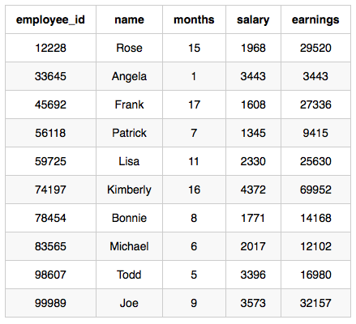

where employee_id is an employee's ID number, name is their name, months is the total number of months they've been working for the company, and salary is the their monthly salary.

Sample Output

69952 1

Explanation

The table and earnings data is depicted in the following diagram (見上).

The maximum earnings value is 69952. The only employee with earnings = 69952 is Kimberly, so we print the maximum earnings value (69952) and a count of the number of employees who have earned $69952 (which is 1) as two space-separated values.

History:
E1沒做出來.

以下代碼的理解(跟SQL-quick-pick-up中的那個Group by例子一樣的理解方式):
先按earnings group好,
再對每個group, 得到earnings和count, 用一行來表示該group的earnings和count,
再將所有行以earnings來降序排序
最後只返回最前面的一行.

Top Solution:
select (salary * months) as earnings, count(*)
from employee
group by 1 #本句也可以寫為group by earnings, 也能通過.
order by earnings desc
limit 1;

SELECT account_id, open_emp_id
^^^^ ^^^^
1 2

FROM account
GROUP BY 1;
In above query GROUP BY 1 refers to the first column in select statement which is account_id.

You also can specify in ORDER BY.

Note : The number in ORDER BY and GROUP BY always start with 1 not with 0.

Weather Observation Station 2, Easy

Query the following two values from the STATION table:

1. The sum of all values in LAT_N rounded to a scale of 2 decimal places.
2. The sum of all values in LONG_W rounded to a scale of 2 decimal places.
Input Format

The STATION table is described as follows: (STATION table圖見本文件夾).

where LAT_N is the northern latitude and LONG_W is the western longitude.

Output Format

Your results must be in the form:

lat lon
where lat is the sum of all values in LAT_N and lon is the sum of all values in LONG_W. Both results must be rounded to a scale of 2 decimal places.

History:
E1一分鍾寫好, 一次通過. Discussion中也是這樣寫的.

E1的代碼:
SELECT ROUND(SUM(LAT_N), 2), ROUND(SUM(LONG_W), 2)
FROM STATION;

SELECT ROUND(column_name,decimals) FROM table_name;
Parameter Description
column_name Required. The field to round.
decimals Required. Specifies the number of decimals to be returned. 即保留小數點後多少位.
ROUND函數是按四舍五入弄的, 但對於五, 到底該往上弄還是往下弄, 此文有介紹: http://www.w3schools.com/Sql/sql_func_round.asp

Weather Observation Station 13, Easy

Query the sum of Northern Latitudes (LAT_N) from STATION having values greater than 38.7880 and less than 137.2345. Truncate your answer to 4 decimal places.

Input Format

The STATION table is described as follows (STATION table圖見本文件夾).

where LAT_N is the northern latitude and LONG_W is the western longitude.

History:
E1最開始把題目看錯了, 沒看到sum. 改後即通過. Discussion中也是這樣寫的.

E1的代碼:
SELECT TRUNCATE(SUM(LAT_N), 4)
FROM STATION
WHERE LAT_N > 38.7880 AND LAT_N < 137.2345;

TRUNCATE() returns a number after truncated to certain decimal places.
TRUNCATE(N, D);
Arguments
Name Description
N A number which is to be truncated up to D decimal places.
D A number indicating up to how many decimal places, N is to be truncated. 即保留小數點後多少位.

Weather Observation Station 14, Easy

Query the greatest value of the Northern Latitudes (LAT_N) from STATION that is less than 137.2345. Truncate your answer to decimal places.

Input Format

The STATION table is described as follows (STATION table圖見本文件夾).

where LAT_N is the northern latitude and LONG_W is the western longitude.

History:
E1一分鍾寫好, 一次通過. Discussion中也是這樣寫的.

E1的代碼:
SELECT TRUNCATE(MAX(LAT_N), 4)
FROM STATION
WHERE LAT_N < 137.2345

Weather Observation Station 15, Easy

題目意思不明確. 題目的意思就是: 在STATION這個表中找出這麼一些行(稱這些行為A類行): A類行要滿兩個要求: 一是A類行的LAT_N都為 「LAT_N在表中的最大值」, 二是A類行的LAT_N都要小於 137.2345. 最後要返回的是所有A類行的LONG_W值, 並且這些LONG_W值要round to 4 decimal places.

Query the Western Longitude (LONG_W) for the largest Northern Latitude (LAT_N) in STATION that is less than 137.2345. Round your answer to 4 decimal places.

Input Format

The STATION table is described as follows: (STATION table圖見本文件夾).

where LAT_N is the northern latitude and LONG_W is the western longitude.

History:
E1幾分鍾寫好, 但把題目中的Round看成了Truncate, 改後即通過. Discussion中基本上也是這樣寫的.

E1的代碼:
SELECT ROUND(LONG_W, 4)
FROM STATION
WHERE LAT_N IN
(SELECT MAX(LAT_N)
FROM STATION
WHERE LAT_N < 137.2345);

Weather Observation Station 16, Easy

Query the smallest Northern Latitude (LAT_N) from STATION that is greater than 38.7780. Round your answer to decimal places.

Input Format

The STATION table is described as follows: (STATION table圖見本文件夾).

where LAT_N is the northern latitude and LONG_W is the western longitude.

History:
E1幾秒鍾寫好, 一次通過. Discussion中差不多也是這樣寫的.

E1的代碼:
SELECT ROUND(MIN(LAT_N), 4)
FROM STATION
WHERE LAT_N > 38.7780

Weather Observation Station 17, Easy

本題跟Weather Observation Station 15差不多.

Query the Western Longitude (LONG_W) for the smallest Northern Latitude (LAT_N) in STATION that is greater than 38.7780. Round your answer to 4 decimal places.

Input Format

The STATION table is described as follows (STATION table圖見本文件夾).

where LAT_N is the northern latitude and LONG_W is the western longitude.

History:
E1一分鍾寫好, 一次通過. Discussion中也是這樣寫的或類似方法寫的.

E1的代碼:
SELECT ROUND(LONG_W, 4)
FROM STATION
WHERE LAT_N IN
(SELECT MIN(LAT_N)
FROM STATION
WHERE LAT_N > 38.7780);

Weather Observation Station 18, Medium

Consider P_1 (a, b) and P_2 (c, d) to be two points on a 2D plane.

- a happens to equal the minimum value in Northern Latitude (LAT_N in STATION).
- b happens to equal the maximum value in Northern Latitude (LAT_N in STATION).
- c happens to equal the minimum value in Western Longitude (LONG_W in STATION).
- d happens to equal the maximum value in Western Longitude (LONG_W in STATION).

Query the Manhattan Distance between points P_1 and P_2 and round it to a scale of 4 decimal places.

Input Format

The STATION table is described as follows (STATION table圖見本文件夾).

where LAT_N is the northern latitude and LONG_W is the western longitude.

History:
E1幾分鍾寫好, 一次通過. Discussion中也是這樣寫的或類似方法寫的.

E1的代碼:
SELECT ROUND(ABS(MIN(LAT_N) - MIN(LONG_W)) + ABS(MAX(LAT_N) - MAX(LONG_W)), 4) #ABS(number) returns the absolute value of a number.
FROM STATION

Manhattan Distance:

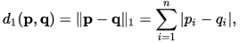

Weather Observation Station 19, Medium

Consider P_1 (a, b) and P_2 (c, d) to be two points on a 2D plane where (a, b) are the respective minimum and maximum values of Northern Latitude (LAT_N) and (c, d) are the respective minimum and maximum values of Western Longitude (LONG_W) in STATION.

Query the Euclidean Distance between points P_1 and P_2 and format your answer to display 4 decimal digits.

Input Format

The STATION table is described as follows (STATION table圖見本文件夾).

where LAT_N is the northern latitude and LONG_W is the western longitude.

History:
E1幾分鍾寫好, 一次通過. E1是用的乘法表示平方, Top Solution是用的POWER函數. E1那樣可能要多算幾次MAX和MIN, 所以以後用Top Solution.

Top Solution:
SELECT ROUND(SQRT(POWER(MAX(LONG_W) - MAX(LAT_N),2) + POWER(MIN(LONG_W) - MIN(LAT_N), 2)), 4)
FROM STATION;

E1的代碼:
SELECT ROUND(SQRT((MIN(LAT_N) - MIN(LONG_W)) * (MIN(LAT_N) - MIN(LONG_W)) + (MAX(LAT_N) - MAX(LONG_W)) * (MAX(LAT_N) - MAX(LONG_W))), 4)
FROM STATION

SQRT(number) returns the square root of a non-negative number of the argument.
POWER(3, 2) returns the value of 3^2, i.e. 9.

Weather Observation Station 20, Medium

A median is defined as a number separating the higher half of a data set from the lower half. Query the median of the Northern Latitudes (LAT_N) from STATION and round your answer to 4 decimal places.

Note: Oracle solutions are not permitted for this challenge.

Input Format

The STATION table is described as follows (STATION table圖見本文件夾).

where LAT_N is the northern latitude and LONG_W is the western longitude.

History:
E1沒做出來.

Wiki中對median的定義:

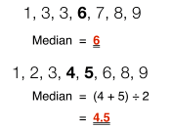

Top Solution(不用, 只看看, 因為只適用於奇數個數的情況):

看以下代碼時, 注意用我SQL-quick-pick-up對如何讀correlated queries的解釋. 以下代碼的意思即 找一個數, 使得小於它的數的個數 等於 大於它的數的個數. 這顯然只適用於奇數個數的情況(Discussion中也有人這樣說了). 以下代碼能通過, 是因為Hackerrank上只有一個test case. 更General的方法見下面網上的代碼.

Select round(S.LAT_N,4) mediam
from station S
where (select count(Lat_N)
from station
where Lat_N < S.LAT_N ) =
(select count(Lat_N)
from station
where Lat_N > S.LAT_N)

網上的代碼(大概看看即可, 面試應該不會要求寫這麼複雜的):

Simple way to calculate median with MySQL

要看懂以下代碼, 要补充以下知識:

What does the “@” symbol do in SQL?
The @... means it's a parameter that you will supply a value for later in your code. This is the best way of protecting against SQL injection. Create your query using parameters, rather than concatenating strings and variables. The database engine puts the parameter value into where the placeholder is, and there is zero chance for SQL injection.

What does “:=” do?
It's the assignment operator in Pascal and is often used in proofs and pseudo-code. It's the same thing as = in C-dialect languages.
Historically, computer science papers used = for equality comparisons and ← for assignments. Pascal used := to stand in for the hard-to-type left arrow. C went a different direction and instead decided on the = and == operators.

What does “WHERE 1” mean in SQL?
It means ALWAYS TRUE so it won't have any filtering impact on your query. Query planner will probably ignore that clause.

SELECT avg(t1.val) as median_val FROM (
SELECT @rownum:=@rownum+1 as `row_number`, d.val
FROM data d, (SELECT @rownum:=0) r
WHERE 1
-- put some where clause here
ORDER BY d.val
) as t1,
(
SELECT count(*) as total_rows
FROM data d
WHERE 1
-- put same where clause here
) as t2
WHERE 1
AND t1.row_number in ( floor((total_rows+1)/2), floor((total_rows+2)/2) );

Basic Join

Asian Population, Easy

Given the CITY and COUNTRY tables, query the sum of the populations of all cities where the CONTINENT is 'Asia'.

Note: CITY.CountryCode and COUNTRY.Code are matching key columns.

Input Format

The CITY and COUNTRY tables are described as follows (CITY和COUNTRY圖見本文件夾).

History:
E1最開始以為 CONTINENT是CITY表中的, 寫成的CITY.CONTINENT, 結果怎麼都通不過. 後來run code之後才發現 CONTINENT是COUNTRY表中的, 改後即通過. Discussion中沒人給出代碼.

E1的代碼一:
SELECT SUM(CITY.POPULATION) #注意必須寫加CITY, 因為COUNTRY也有 POPULATION
FROM CITY, COUNTRY
WHERE COUNTRYCODE = CODE AND CONTINENT = 'ASIA';

E1的代碼二:
SELECT SUM(CITY.POPULATION)
FROM CITY JOIN COUNTRY ON COUNTRYCODE = CODE
WHERE CONTINENT = 'ASIA';

African Cities, Easy

Given the CITY and COUNTRY tables, query the names of all cities where the CONTINENT is 'Africa'.

Note: CITY.CountryCode and COUNTRY.Code are matching key columns.

Input Format

The CITY and COUNTRY tables are described as follows (CITY和COUNTRY圖見本文件夾).

History:
E1一分鍾寫好, 一次通過. Discussion中也是類似代碼.

E1的代碼:
SELECT CITY.NAME
FROM CITY, COUNTRY
WHERE CITY.COUNTRYCODE = COUNTRY.CODE AND COUNTRY.CONTINENT = 'AFRICA';

Average Population of Each Continent, Easy

Given the CITY and COUNTRY tables, query the names of all the continents (COUNTRY.Continent) and their respective average city populations (CITY.Population) rounded down to the nearest integer.

Note: CITY.CountryCode and COUNTRY.Code are matching key columns. Do not include continents without cities in your output.

Input Format

The CITY and COUNTRY tables are described as follows (CITY和COUNTRY圖見本文件夾).

History:
E1最開始將題目中的round down看成了round, 改後即通過. Discussion中也差不多是這麼寫的.

E1的代碼:
SELECT COUNTRY.CONTINENT, FLOOR(AVG(CITY.POPULATION))
FROM CITY, COUNTRY
WHERE CITY.COUNTRYCODE = COUNTRY.CODE
GROUP BY COUNTRY.CONTINENT

The Report, Medium

注意, 題目意思有問題, 題目中說:
Finally, if the grade is lower than 8, use "NULL" as their name and list them by their marks in ascending order.
Discussion中說:
However, the test code is expecting these to be ordered by grade first (descending) then by mark (ascending).
實際上, 由已通過的代碼可以看出, 結果中所有行都是按
order by Grades.Grade desc, Students.Name, Students.Marks asc
這樣的順序來排序的.

You are given two tables: Students and Grades. Students contains three columns ID, Name and Marks.

Students Grades Sample Input
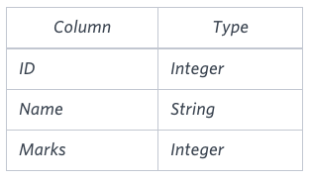
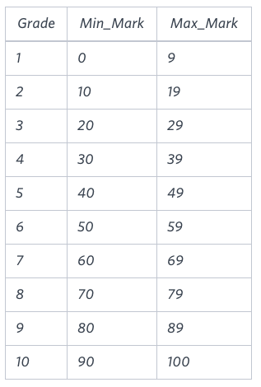
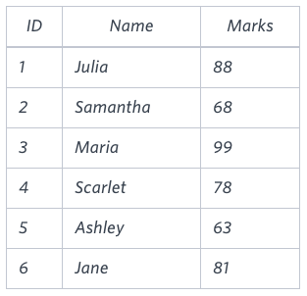

Explanation
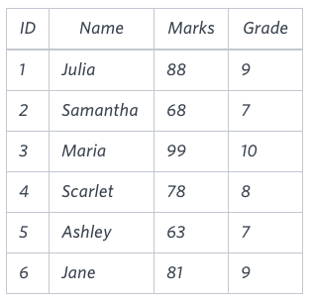

Grades contains the following data (見上)

Ketty gives Eve a task to generate a report containing three columns: Name, Grade and Mark (應為Marks). Ketty doesn't want the NAMES of those students who received a grade lower than 8. The report must be in descending order by grade -- i.e. higher grades are entered first. If there is more than one student with the same grade (1-10) assigned to them, order those particular students by their name alphabetically. Finally, if the grade is lower than 8, use "NULL" as their name and list them by their marks in ascending order.

Write a query to help Eve.

Sample Output

Maria 10 99
Jane 9 81
Julia 9 88
Scarlet 8 78
NULL 7 63
NULL 7 68

Note

Print "NULL" as the name if the grade is less than 8.

Explanation

Consider the following table with the grades assigned to the students (見上).

So, the following students got 8, 9 or 10 grades:

Maria (grade 10)
Jane (grade 9)
Julia (grade 9)
Scarlet (grade 8)

History:
E1沒做出來.

Top Solution:
select if(Grades.Grade < 8, concat('NULL'), Students.Name), Grades.Grade, Students.Marks
from Students inner join Grades # inner join寫為join, 也能通過.
on Students.Marks >= Grades.Min_Mark and Students.Marks <= Grades.Max_Mark
group by Grades.Grade desc, Students.Name, Students.Marks asc
#上句將group by改為order by也能通過, 建議用order by, 意思更明確.

CONCAT(str1,str2,…):
返回结果为连接参数产生的字符串, 如有任何一个参数为NULL, 则返回值为NULL. 例:
select concat('10');
10

select concat('11','22','33');
112233

select concat('11','22',null);
NULL

IF(expression, expr_true, expr_false):
if the first expression is true, not zero and not NULL,
it returns the second expression.
Otherwise, it returns the third expression.
Eg: SELECT IF(1>3,'true','false');

Top Competitors, Medium

Julia just finished conducting a coding contest, and she needs your help assembling the leaderboard! Write a query to print the respective hacker_id and name of hackers who achieved full scores for more than one challenge. Order your output in descending order by the total number of challenges in which the hacker earned a full score. If more than one hacker received full scores in same number of challenges, then sort them by ascending hacker_id.

Input Format

The following tables contain contest data (原文不同的表都是竪著排的, 我將它們放在了同一行, 方便看):
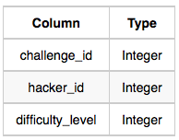
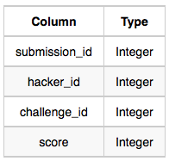
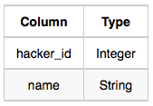
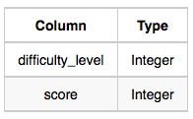

Hackers Difficulty

Challenges
Submissions

Hackers: The hacker_id is the id of the hacker, and name is the name of the hacker.

Difficulty: The difficult_level is the level of difficulty of the challenge, and score is the (full) score of the challenge for the difficulty level.

Challenges: The challenge_id is the id of the challenge, the hacker_id is the id of the hacker who created the challenge, and difficulty_level is the level of difficulty of the challenge.

Submissions: The submission_id is the id of the submission, hacker_id is the id of the hacker who made the submission, challenge_id is the id of the challenge that the submission belongs to, and score is the score of the submission.

Sample Input

Hackers Table: (竪的表, 很高很窄, 刷屏狗, 已省).

Difficulty Table: (竪的表, 很高窄, 刷屏狗, 已省).

Challenges Table: (竪的表, 很高窄, 刷屏狗, 已省).

Submissions Table (竪的表, 很高窄, 刷屏狗, 已省).

Sample Output

90411 Joe

Explanation

Hacker 86870 got a score of 30 for challenge 71055 with a difficulty level of 2, so 86870 earned a full score for this challenge.

Hacker 90411 got a score of 30 for challenge 71055 with a difficulty level of 2, so 90411 earned a full score for this challenge.

Hacker 90411 got a score of 100 for challenge 66730 with a difficulty level of 6, so 90411 earned a full score for this challenge.

Only hacker 90411 managed to earn a full score for more than one challenge, so we print the their hacker_id and name as 2 space-separated values.

History:
E1沒做出來, 後來看了Discussion, 才發現可以用having, E1基本上都忘了還有having語句存在. 然然根据Discussion將我E1的代碼改了改, 即通過.

E1改了後的代碼:
select H.hacker_id as HID, H.name
from Hackers as H, Submissions as S, Challenges as C, Difficulty as D
where H.hacker_id = S.hacker_id and S.challenge_id = C.challenge_id and C.difficulty_level = D.difficulty_level and S.score = D.score
group by H.hacker_id
having count(H.hacker_id) > 1
order by count(H.hacker_id) desc, HID;

Ollivander's Inventory, Medium

Harry Potter and his friends are at Ollivander's with Ron, finally replacing Charlie's old broken wand.

Hermione decides the best way to choose is by determining the minimum number of gold galleons needed to buy each non-evil wand of high power and age. Write a query to print the id, age, coins_needed, and power of the wands that Ron's interested in, sorted in order of descending power. If more than one wand has same power, sort the result in order of descending age. 日他大爺, 題目中還有個要求沒說, 就是在結果中, 對於那些俱有相同power和相同age的行, 只選出coins_needed最小的一行來, 作為最終結果, 例如對於以下三行:
id age coins_needed power
15 40 6018 7
17 40 8798 7
6 40 6773 7

只選
15 40 6018 7
這一行, 因為它 coins_needed最小.

Input Format

The following tables contain data on the wands in Ollivander's inventory:

Wands Wands_Property Wands_Property input Wands input
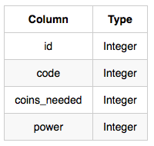
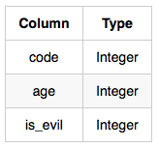
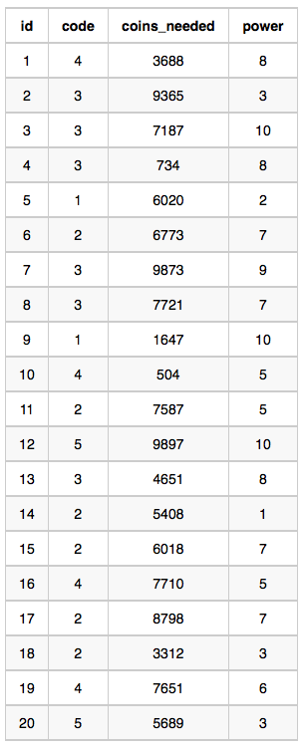
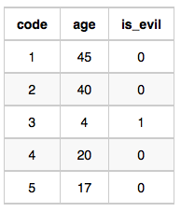

Data for wands of age 45 (code 1) Data for wands of age 40 (code 2)
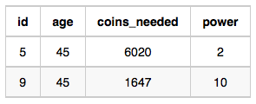
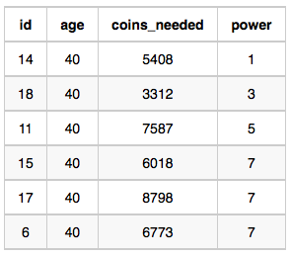

Data for wands of age 20 (code 4)
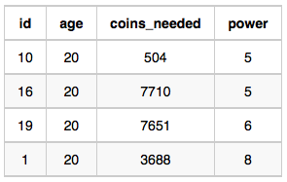
Data for wands of age 17 (code 5)
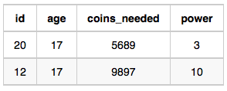

Wands: The id is the id of the wand, code is the code of the wand, coins_needed is the total number of gold galleons needed to buy the wand, and power denotes the quality of the wand (the higher the power, the better the wand is).

Wands_Property: The code is the code of the wand, age is the age of the wand, and is_evil denotes whether the wand is good for the dark arts. If the value of is_evil is 0, it means that the wand is not evil. The mapping between code and age is one-one, meaning that if there are two pairs, (code_1, age_1) and (code_2, age_2), then code_1 != code_2 and age_1 != age_2.

Sample Input .

Wands Table: (見上). Wands_Property Table: (見上).

Sample Output

9 45 1647 10
12 17 9897 10
1 20 3688 8
15 40 6018 7
19 20 7651 6
11 40 7587 5
10 20 504 5
18 40 3312 3
20 17 5689 3
5 45 6020 2
14 40 5408 1
Explanation

The data for wands of age 45 (code 1): (見上).

The minimum number of galleons needed for wand(age = 45, power = 2) = 6020
The minimum number of galleons needed for wand(age = 45, power = 10) = 1647
The data for wands of age 40 (code 2): (見上).

The minimum number of galleons needed for wand(age = 40, power = 1) = 5408
The minimum number of galleons needed for wand(age = 40, power = 3) = 3312
The minimum number of galleons needed for wand(age = 40, power = 5) = 7587
The minimum number of galleons needed for wand(age = 40, power = 7) = 6018

The data for wands of age 20 (code 4): (見上).

The minimum number of galleons needed for wand(age = 20, power = 5) = 504
The minimum number of galleons needed for wand(age = 20, power = 6) = 7651
The minimum number of galleons needed for wand(age = 20, power = 8) = 3688

The data for wands of age 17 (code 5): (見上).

The minimum number of galleons needed for wand(age = 17, power = 3) = 5689
The minimum number of galleons needed for wand(age = 17, power = 10) = 9897

History:
E1根本都不知道題目還有個要求沒說, 所以沒通過, 直接看的Discussion.

Top Solution:
select w.id, p.age, w.coins_needed, w.power
from Wands as w join Wands_Property as p on (w.code = p.code)
where p.is_evil = 0 and w.coins_needed =
(select min(coins_needed) #此 coins_needed可以寫為w1. coins_needed, 但不能寫為w. coins_needed
from Wands as w1 join Wands_Property as p1 on (w1.code = p1.code)
where w1.power = w.power and p1.age = p.age)
order by w.power desc, p.age desc

Challenges, Medium

Julia asked her students to create some coding challenges. Write a query to print the hacker_id, name, and the total number of challenges created by each student. Sort your results by the total number of challenges in descending order. If more than one student created the same number of challenges, then sort the result by hacker_id. If more than one student created the same number of challenges and the count is less than the maximum number of challenges created, then exclude those students from the result.

Input Format

The following tables contain challenge data:

Hackers Challenges
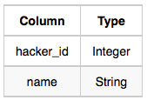
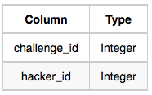

Hackers: The hacker_id is the id of the hacker, and name is the name of the hacker.

Challenges: The challenge_id is the id of the challenge, and hacker_id is the id of the student who created the challenge.

Sample Input 0

Hackers Table (刷屏, 且沒用, 故省).

Challenges Table (刷屏, 且沒用, 故省).

Sample Output 0

21283 Angela 6
88255 Patrick 5
96196 Lisa 1
Sample Input 1

Hackers Table (刷屏, 且沒用, 故省).
Challenges Table (刷屏, 且沒用, 故省).

Sample Output 1

12299 Rose 6
34856 Angela 6
79345 Frank 4
80491 Patrick 3
81041 Lisa 1
Explanation

For Sample Case 0, we can get the following details:

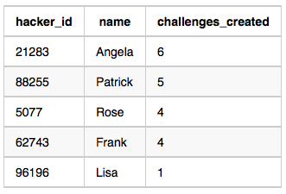

Students 5077 and 62743 both created 4 challenges, but the maximum number of challenges created is 6 so these students are excluded from the result.

For Sample Case 1, we can get the following details:

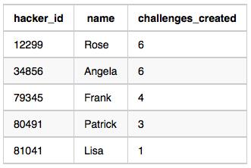

Students 12299 and 34856 both created 6 challenges. Because 6 is the maximum number of challenges created, these students are included in the result.

History:
E1沒做出來.

Top Solution (簡化後):

-- 以下代碼得票最多. 原代碼在or後那段中還要多一層select, Discussion中有人指出說沒必要, 我就將其刪除了. 另外 我還做了好幾處簡化. 以下代碼能通過. 䀆管做了簡化, 以下仍是我目前見過的最複雜的SQL代碼.

select c.hacker_id, h.name, count(*) as total
from challenges c inner join hackers h
on h.hacker_id = c.hacker_id
group by c.hacker_id having

-- 以下即要求total等於 提出challenge最多的那個人 提出的challenge個數
total =
(select count(*) as tot1
from challenges c1
group by c1.hacker_id
ORDER BY tot1 desc limit 1)

or

-- 以下即要求total 為 這樣一種 challenge個數: 即只有一個人提出了 這麼多個數的challenge
-- 以下藍色部分即為一個表, 此表名字叫t.
total in
(select t.tot2
from (select count(*) as tot2, c2.hacker_id
from challenges c2
group by c2.hacker_id) as t
group by t.tot2
having count(t.hacker_id) = 1)

order by total desc, h.hacker_id;

Contest Leaderboard, Medium

You did such a great job helping Julia with her last coding contest challenge that she wants you to work on this one, too!

The total score of a hacker is the sum of their maximum scores for all of the challenges. Write a query to print the hacker_id, name, and total score of the hackers ordered by the descending score. If more than one hacker achieved the same total score, then sort the result by ascending hacker_id. Exclude all hackers with a total score of 0 from your result. 注意看後面對Sample Output的解釋.

Input Format

The following tables contain contest data:

Hackers Submissions
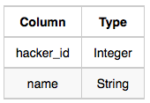
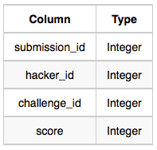

Hackers: The hacker_id is the id of the hacker, and name is the name of the hacker.

Submissions: The submission_id is the id of the submission, hacker_id is the id of the hacker who made the submission, challenge_id is the id of the challenge for which the submission belongs to, and score is the score of the submission.

Sample Input

Hackers Table: Submissions Table:
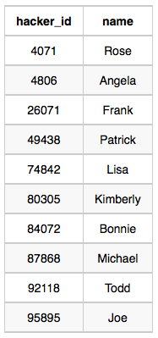
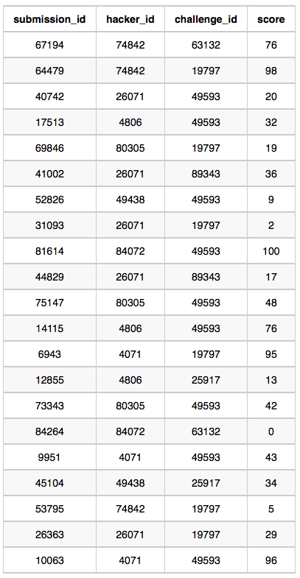

Sample Output

4071 Rose 191
74842 Lisa 174
84072 Bonnie 100
4806 Angela 89
26071 Frank 85
80305 Kimberly 67
49438 Patrick 43

Explanation

Hacker 4071 submitted solutions for challenges 19797 and 49593, so the total score
= 95 + max(43, 96) = 191.

Hacker 74842 submitted solutions for challenges 19797 and 63132, so the total score
= max(98, 5) + 76 = 174.

Hacker 84072 submitted solutions for challenges 49593 and 63132, so the total score
= 100 + 0 = 100.

The total scors for hackers 4806, 26071, 80305, and 49438 can be similarly calculated.

History:
E1晚上兩三點做的, 剛做了上題那複雜的, 現在太困了, 就直接看的Discussion.

Top Solution:

SELECT h.hacker_id, h.name, sum(scr) as tot
# 以下即h join chart 1
# 以下藍色部分即為一個表, 此表名字叫chart1.
FROM Hackers h,
(SELECT s2.hacker_id as hac_id, s2.challenge_id as ch_id, max(s2.score) as scr
FROM Submissions s2
GROUP BY s2.hacker_id, s2.challenge_id
having scr > 0
) AS chart1
WHERE h.hacker_id = hac_id
GROUP BY h.hacker_id
ORDER BY tot DESC, h.hacker_id

由以上代碼可總結出:
若是
SELECT max(...)
FROM ...
GROUP BY A, B
則每個group是A和B一起弄成的group.
SELECT中的max就是在每個這樣的group中求的.

Advanced Join (沒做)
Alternative Queries (沒做)

